2-15-2024
Instructions
T-Rex/Raptor front rest and the 5-Axis Tops
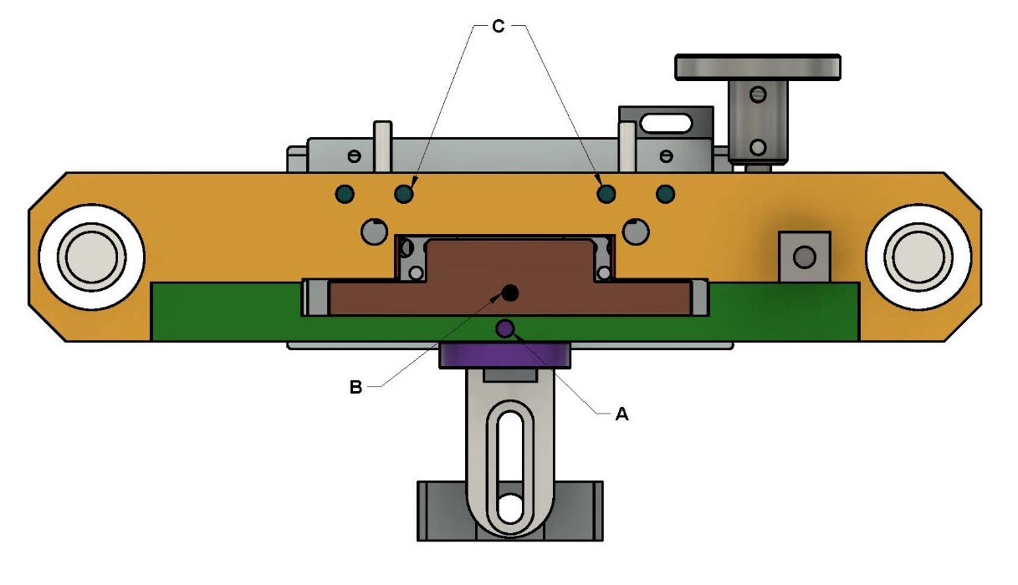
ILLUSTRATION #1-BOTTOM SIDE OF THE BRIDGE
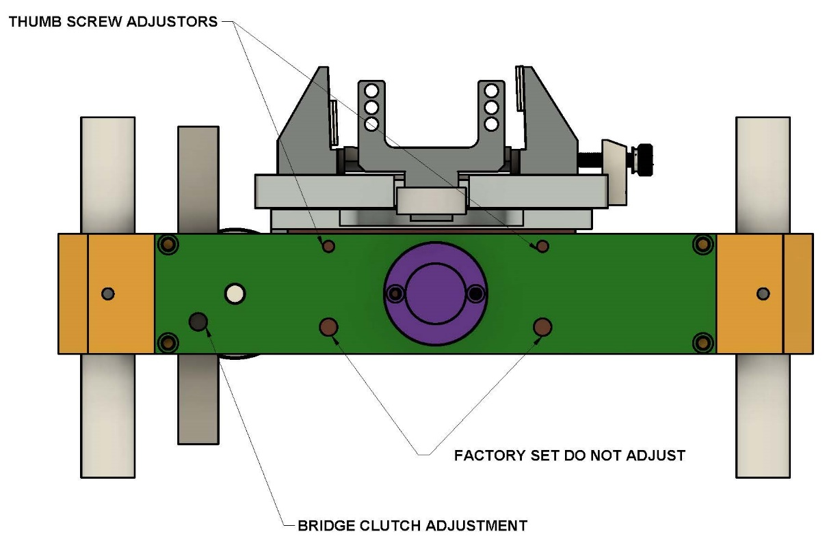
ILLUSTRATION #2-TARGET SIDE OF THE BRIDGE

Introduction
First, let me say, thank you for purchasing my front rest or 5-Axis top. These products were designed and developed over several years of testing at F-Class matches around the country. As a long-range competitor, I have used most front rests available over the years and they all have features I like, but also have deficiencies and lack features I have wanted in a front rest. I started by making a list of features I would love to see in one rest. The original T Rex met every one of these goals and I even discovered a few unique features along the way. When it comes to my personal shooting, I have never been one to choose economy over quality and generally feel that “good is not cheap and cheap is not good” For the front rest I put my name on I did not start with a price point in mind, but instead just started with a blank page and set out to build the very best front rest I could. The T Rex/Raptor and 5-Axis top is the BEST I can build.
Dimensions:
Footprint of the original solid base T-Rex base is 12.5” wide and 10” front to back. The folding Raptor is 19.5” wide and 9.5” front to back.
Vertical adjustment of the bridge is 5.125” for both models. Weight of the new aluminum base T-Rex is 17lb, with the all-aluminum Raptor being 15Lbs.
Protective finishes
• The Raptors folding base, as well as the new T-Rex base plate, along with the bridge assembly is all machined from solid 6061-T6 aluminum. Hard anodizing in matt black is applied to the aluminum parts for long-term durability and good looks.

Features and Adjustments:
The Rodzilla 5-Axis Top
• Both models utilize a very innovative 5-Axis top that features a rotating top plate. This feature means you no longer need to have the rest set squarely to the target to get a consistent set up from one relay to the next. The top plate rotates on Teflon bearing plates which corrects any misalignment with the target therefore avoiding binding during tracking under recoil for less vertical shot disbursement. This feature also maintains a consistent amount of breakaway or drag when you move your rear bag left to right to align with your target. Tracking under recoil is also consistent from one set up to another throughout an entire match for improved scores. Because there is zero play in the Teflon bearing plates there is no need to lock the top plate in position once you are aligned with your target. Just line up with your target and start shooting.
• The Rodzilla 5-Axis tops feature a choice of several ways to guide your rifles forearm.
There are two styles of (adjustable for width) blocks which are explained below. For both styles we use a pair of very small (one inch long) sand bag assemblies which the rifle sets on and mounted on either side. This design provides several advantages over the more traditional one-piece top sand bag arrangements. First, the lower sand bags toggle fore and aft. This feature means you no longer need to level the front leg of the rest since the sand bags self-level every time for a consistent contact patch on the bottom outside edges of your forearm. Secondly, the amount of sand compression is limited and controlled so settling unevenly is not possible which keeps the firearm level, left to right, from the first shot to the last shot of a string unlike other rests. Also, this unique sand rail configuration creates a very low contact patch with very little drag and offers a high level of consistency in tracking from relay to relay.
The high-quality bubble level on the 5-Axis top is unlike other rests that place the level under the rifle where you cannot see your level with your rifle in place. We place our level out on the outer edges so you will always have your level in view. Set it up on the left or right depending on what works best for you. There were three sets of mounting holes on early models, then 4 sets of holes on later models up until the spring of 2024 when we changed to slots for adjusting the width of the top blocks (explained below) allowing for adjustments from 1-3/4” (for the narrowest) to just over 5” for the widest forearm. Also, in the spring of 2024 (our current version) we added a micro adjustment block to the left-hand side of the top plate with a thumb screw to accurately adjust the gap between the blocks for best tracking. Note: this micro adjusting block is designed to work with 3” wide forearms. These micro-adjustment blocks are retrofittable and can be purchased on our home page.as an accessory.
•Our dual forearm stop pivots radially along with the top plate as it rotates and allows for equal contact on both sides of your forearm as it returns to battery. The two-point forearm stop is also adjustable for length on a slotted front post. The idea here is to allow the rifles forearm to bump up against two nylon bumpers so the force on both sides of your forearm is always equal. The two nylon bump stops are also adjustable for height by placing them in a series of vertical holes to best fit your rifles forearm. Note: For sporter rifles and AR style forearms we offer a set of 45-degree guide rails with felt tops for the forearm to ride on. We also offer a single forearm stop which is adjustable for height. These items are available on the home page as accessories.

There Are Two styles of Adjustable Top Blocks

T3 Felt Lined Top Blocks(default)
The new T3 (patent pending technology) felt lined top blocks are the default for our 5-Axis tops and feature a 1/8” thick felt contact patch for the forearmed to slide against. By designing the vertical faces on these blocks to be parallel to each other but turned clockwise a few degrees the rifle is blocked from counter-clockwise rotational torque under recoil while suffering from too much clamping force. Adjust the T3 felt blocks to provide just a bit of compression. Note: Felt also dampens vibrations, or harmonics in the stock better than other material. These blocks are light weight and adjust from 1-3/4” wide to over 5” wide.
T3 Sand Bag Design (legal for F-Open)
The new T3 (patent pending) sand bag top blocks meet the new (2024) rules requiring the gun to be in contact with sand bags only. Adjusting the width of these blocks is the same as the felt version above. However, these blocks utilize a new technology to greatly reduce the counter rotation of the rifle stock under recoil due to torque. By placing the left sand bag high on the forearm and low on the right side the ability for the rifle to roll counter clockwise is greatly limited and without adding excessive drag.

Fixed width option:
IBS top (benchrest legal)
The IBS legal top is mounted to the same 5-Axis top assembly but uses an aluminum block to hold a one-piece sand bag instead of the adjustable width T3 top blocks described above. The IBS top blocks feature adjustable ends with thumb screws to tension the sides of the sand bag for a perfect fit against the forearm. We stock the new style Farley size Edgewood bags which come in 3” or 4” widths. Note: the IBS top block will only accept the new style Farley size one pc bags.

Remote vertical adjustment of the crosshairs
• The coarse vertical bridge adjustment can be accomplished while in position behind the rifle and looking through the scope. Place your hand on the ground and hold the tip of the joystick in a comfortable controlled manner. Now with the long drive rod (which is provided) engage the drive lug which rotates the pinion to raise and lower bridge. clockwise to lift the bridge on the geared rack and counterclockwise lowers the bridge on the geared rack. Locking the bridge is not necessary when the clutch is adjusted properly (see instructions below). Once the bridge is adjusted just pull back on the rod to disengage the drive rod and set it aside. You can reattach the drive rod anytime during a relay without getting out of position. The bridge travels up and down on double sealed ball bushings running on hardened steel vertical 1” posts. This design allows for very low friction and no play or movement of the bridge assembly except in the vertical plane. Note: there is also a knurled hand operated drive wheel in addition to the drive rod. This feature allows for adjusting the bridge by hand if your drive tool is not with you.
The Bridge Clutch adjustment
• There is set screw (see diagram #2) on of the bridge directly in line with the geared rack and low on the bridge assembly. This set screw loads a friction clutch spring and clutch disk against the target side of the geared rack creating friction. This arrangement allows you add just enough friction to hold the weight of your rifle. For these clutch adjustments use the 3/16” Allen wrench provided and start with about 1/8 turn or 45 degrees after the set screw contacts the friction disk. It does not take a lot of rotation on the set screw to apply a lot of friction. Just go a little at a time or it will require more force than necessary to lower and raise your bridge. The idea is to adjust the set screw/disk just enough to hold the weight of the rifle. When properly adjusted the drive rod will move the bridge up and down smoothly with low to moderate effort while looking through the scope but it will not move from the weight of the rifle setting on it, or under recoil. NOTE: We set the friction clutch to hold 15Lb which is approximately the weight of the forearm on a 22Lb rifle.
2 Thumb Screws Adjusters on the Target Side of the Bridge
• Unlike all other rests the T-Rex features double sealed ball bushings for vertical and horizontal movement. This design allows for very low friction of the X-Y movement. There are 4 of these ball bushings for horizontal and two more for vertical. These ball bushings are sealed and run on very hard, polished guide rods. There is no maintenance required. There are two ¼-28 thumb screws (black knobs) on the target side of the bridge on either side of the front joystick bearing housing (see diagram #2). These two thumb screws bear against Teflon wear pads on the front of the X-Y mechanism. Adjust these two thumb screws inward (about 1/8th turn after touching the Teflon wear pads) just enough to remove the small amount of play front-to back of the top and then lock them in position with the 2 locking collars. Tightening these thumb screws will also add just a bit of resistance to the joy stick movement. We recommend making this adjustment after setting the counter balance as described below. Note: there are 2 set screws (see diagram #2) below the two black thumb screws on the target side of the bridge assembly. Do not adjust these set screws as they are set and locked at the factory to remove the small amount of primary play in the X-Y assembly.
Caution:
• do not over tighten the 2 black thumb screw adjusters or you could damage the ball bushings or rods in the X-Y assembly. And only add this friction after adjusting the counter balance so your balance is not disguised by any excess friction from the Teflon wear pads. NOTE: Remember, the benefit of low friction of the joystick movement is precision of crosshair placement.
The Forward Spherical Bearing Set Screw
•This set screw (see diagram #1 item A) is a bit hard to locate but is the beginning of the process for setting your counter balance and must be retightened after setting the counter balance as described in the next paragraph. Note: there is another set screw (see diagram #1 item B) that holds the center spherical bearing in place and should just be snug. Do not overtighten this set screw or it will take excessive force to move the joy stick.
First run the bridge up to the highest position on the vertical posts so you will have better access to set screw A. located on the target side at the bottom of the bridge where you will see an access hole (you cannot see the set screw). For the first time it might be helpful to turn your rest upside down to locate this small hole. Now use the short end of your 1/8” allen wrench to go up through this hole to engage the forward spherical bearing set screw. Back this set screw off a ½ turn to remove all resistance to the X-Y block so the joystick can float up and down freely without resistance. At this point the joy stick will also spin freely and with your rifle setting on the rest. Also, the joystick will fall and rise loosely without staying in any set position. Now you will be able to adjust the counter balance accurately for your rifles weight as described below in the next section. After the counter balance procedure is completed, you will need to retighten this forward set screw (diagram #1 item A) to add resistance back into the joy stick to keep the joy stick from rotating too freely and to hold it in position anywhere within the joy sticks window of movement without having to hold it by hand.
Setting the counter balance for your rifle weight
• To counter balance the weight of your rifle, merely place your rifle on the rest with the butt of your rifle on a sand bag as you would normally set it up on the firing line. Be sure to attach the joystick as the weight of the joystick will affect your counter balance. Now loosen the two black thumb screws (see diagram #2) on the target side of the bridge that add friction. (See the above instruction regarding X-Y friction) Also with the 1/8’ Allen wrench, back off the forward bearing set screw (see diagram #1item A) and the one in the X-Y block (see diagram #1 item B) as described above to allow the joystick to freely move up and down without any added friction. • There are three counter balance set screws on the bottom of the bridge on the shooter side (see diagram #1 item C) on my early rests and only 2 cap screws on rests built from mid-2023 onward that preload the counter balance springs in the X-Y mechanism which makes the rifle float or balance on the rest. (For the older three spring models) The two set screws in the center are set nearly flush with the bottom of the bridge (Just short of coil bind) there is also another long set screw sticking down from the bottom on the right side of the bridge with about ½” exposed. This fine adjustment screw can be turned by finger pressure. Turn this single set screw in until the weight of your rifle is neutralized or balanced, and the joystick will stay around the center of the window. If your rifle is too light for proper adjustment with the long set screw on the right (older models only) back out the two center screws several turns each to remove counter balance and then readjust the longer fine adjustment screw up or down to fine tune the balance. With proper adjustment your joystick will bounce up from the bottom and fall from the top approximately the same amount when released, again with the rifle on the rest. The joy stick should go equally toward the center when the counter balance springs are set perfectly. Again, by backing out the counter balance set screws the weight of your rifle will cause the joy stick to drop lower and inward with the set screws will cause the joystick to go higher and above center. With the newer 2 spring models you will only need to adjust one or both of the centrally located socket cap screws (see diagram #1 item C) to achieve proper counter balance.
As the T-Rex and Raptors have very little internal X-Y friction you will be able to achieve a perfect counter balance quickly, precisely and without the compromise between counter balance and friction we have all experienced with other front rests. At the top of my website there is a tab for VIDEOS. I have made three videos describing this process that I highly recommend and start with #1 then #2 and #3

Sand feet
• We offer a set of Phoenix style, or bell shaped, sand feet that fit both the Raptor and the new aluminum base T-Rex front rests. They come with a large top knob for height adjustment and a locking collar to hold them in position once leveling is accomplished. They are listed on the home page as an accessory item or in a drop-down box when ordering a rest online
Fitted case
• A custom hard case is an option for the T-Rex or Raptor front rest assembly. The case is made from tough, light-weight, polypropylene copolymer. It has a rugged O-ring seal that makes it air and water tight up to 3ft deep. our case utilizes an automatic pressure release valve so that it adjusts to its environment. It is also ATA/TSA ready for airline travel. The case is lockable with comfort molded handles and spring-loaded latches and features custom cut convoluted open cell foam glued into the lid plus a 1” thick base pad glued into the bottom to lock the T-Rex from shifting around. There are two 4” thick, lift out pieces custom cut to secure the feet, tools, and base during transport. For the Raptor, we offer a soft case option when ordering or sold on the home page as an accessory item.
Maintenance
• For both the Raptor and the T-Rex There is no maintenance required other than drying the unit thoroughly if shot in the rain like any other piece of shooting equipment. Do not place the rest in a sealed case when wet. I recommend a thorough wipe down every month or two with a rust preventive, especially on the vertical guide posts. There is no lube required or recommended beyond the factory applied assembly lube in a few locations for break in purposes.
Lifetime Warranty
• Maybe the best feature of all is it is entirely made in the USA. All Rodzilla shooting products carry a lifetime warranty on workmanship and materials regardless of whether you purchased directly from us or second hand.

Exclusive to the Raptor
Retrofitting a Raptor base onto an existing T-Rex
On both the T-Rex and the Raptor, there is one take down bolt located under the base which screws into the bottom of the geared rack. This take down bolt is all that holds the bridge assembly onto the base/ vertical post assembly. Remove this bolt with an Allen wrench and lift the bridge assemble off the steel T-Rex base and set the bridge assembly aside. Now set the Raptor base with the posts pointing up and the legs unfolded the way you want to shoot. Now carefully lower the bridge assembly down over the posts. Try to engaging the seals on the large ball bushings in unison and lower the bridge assembly onto the Raptor Aluminum base. Hold both the bridge and base together while reinstalling the take down bolt you removed. NOTE: you will need to rotate the legs on the Raptor to gain access to the takedown bolt.

The Raptors Folding legs
All three legs fold in and out for storage and have ball detents. The front leg has a heavy detent when fully extended and two more lighter detents when folded either way back under the base. The two primary legs have light detents whin folded under the base and two heavy detents when extended, the first position is perpendicular or 90 degrees to the base and the second heavy detent stops at an additional 30 degrees. Note: for both positions (legs folded out) use the ¼” pins with the red rubber caps to lock the legs in either position. Just push the pins down through the base plate holes and into the mating holes in the legs.
NOTE: There is a set screw in the bottom of each leg (three total) that pre-loads a spring for the ball detents. These set screws should be nearly flush with the surface of the legs, or just above flush. Too much compression on the ball and detent springs will coil bind the spring and not allow the ball to disengage the detent hole properly. Do not attempt to adjust these three set screws.
Running the two legs forward and the single leg toward the shooter
Remove the take down bolt under the geared rack and lift the bridge assembly off the posts. Rotate the bridge 180 degrees and reinstall it over the vertical guide rods. Carefully turn the assemble over or on its side and reinstall the take down bolt in the opposite side and snug it down. Now the single leg will be coming toward the shooter and the joy stick still operates the bridge as before. UP is always UP and DOWN is always DOWN unlike other rests that are reversed when set up this way.
Modular joystick supplied with both the Raptor and T-rex
The Raptor comes with a modular joystick that allows for quickly changing from a long reach version to a shorter version by merely loosening a thumb screw and changing out the lightweight extensions.
Slide the joy stick adaptor tube (the tube with a bend and two thumb screws) over the joystick stub and snug the thumb screw. Note: If you install the adaptor tube too far onto the joystick stub it can hit the inside of the window opening which limits the travel in both the horizontal and vertical planes. Now just slip in the extension tube of choice and tighten the second thumb screw. The Raptor is supplied with one extension of choice. The longest extension is 12” and can easily be trimmed to a shorter length as needed. Just pull off the black plastic button, trim with a hack saw or tubing cutter and replace the black button. (NOTE: be sure to only cut the painted end of the extension which the black button is attached to)
Alternatively, you may choose to just purchase a 10” or 8” extension and change them out as needed. The extensions are ultra-light so as not to affect the counterbalance of the rest.
Also, the adaptor has 1” of adjustment and the removable extension has another inch of adjustment so you can get exactly the length you want for any rifle length. This modular joy stick will also work on the T-Rex.

